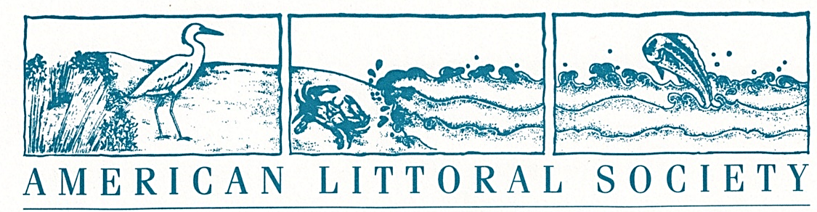

Northeast Chapter ♦ 28 West 9th Road, Broad Channel, NY 11693 ♦ (718) 474-0896

New York State Beach Cleanup
BEACH CLEANUP VOLUNTEER SIGN-IN SHEET
I have read and sign my name to the message below
As a volunteer I agree to take full responsibility for my own actions, safety and welfare. I release and discharge American Littoral Society & its agents from any liability arising from my participation in the NYS Beach Cleanup.
It is important that I have work gloves, appropriate shoes (no bare feet), sun hat, sunscreen and water. I will not pick up needles but will notify the site leader who will put needles and syringes in a container with a secure lid marked ‘Medical Waste’.

Beach or Shoreline______________________________ Town___________________________________

Captain____________________________

Name Organization You Represent E-mail/Phone Number

Name Organization You Represent E-mail/Phone Number

__________________________________________________________________________________________

