10 THINGS YOU CAN DO TO STOP MARINE DEBRIS

- Volunteer for the New York State Beach Cleanup every September.
- Put trash in a secure, lidded receptacle – most marine debris starts out on land.
- Put cigarette butts in ashtrays, not on streets, sidewalks, or beaches.
- Properly recycle everything you can batteries cans, bottles and food containers, newspaper, cell phone, computers, bags, packaging materials, and fishing line. Contact your local sanitation office to discover your recycling options.
- When boating bring your oil can, food wrappers, and cigarette butts back to shore, and be sure to ask your marina to handle waste properly.
- Start conversations that inform and inspire your friends and coworkers to help stop marine debris at the source.
- Bring along your own permanent food containers for picnics instead of using disposable.
- Remember to take your own reusable bags whenever you go shopping.
- Write to companies or visit your own local shops and restaurants and encourage them to reuse, recycle and generate less packaging.
- Write to your elected officials and encourage them to support policies that protect our ocean.

10 THINGS YOU CAN DO TO STOP MARINE DEBRIS

- Volunteer for the New York State Beach Cleanup every September.
- Put trash in a secure, lidded receptacle – most marine debris starts out on land.
- Put cigarette butts in ashtrays, not on streets, sidewalks, or beaches.
- Properly recycle everything you can batteries cans, bottles and food containers, newspaper, cell phone, computers, bags, packaging materials, and fishing line. Contact your local sanitation office to discover your recycling options.
- When boating bring your oil can, food wrappers, and cigarette butts back to shore, and be sure to ask your marina to handle waste properly.
- Start conversations that inform and inspire your friends and coworkers to help stop marine debris at the source.
- Bring along your own permanent food containers for picnics instead of using disposable.
- Remember to take your own reusable bags whenever you go shopping.
- Write to companies or visit your own local shops and restaurants and encourage them to reuse, recycle and generate less packaging.
- Write to your elected officials and encourage them to support policies that protect our ocean.

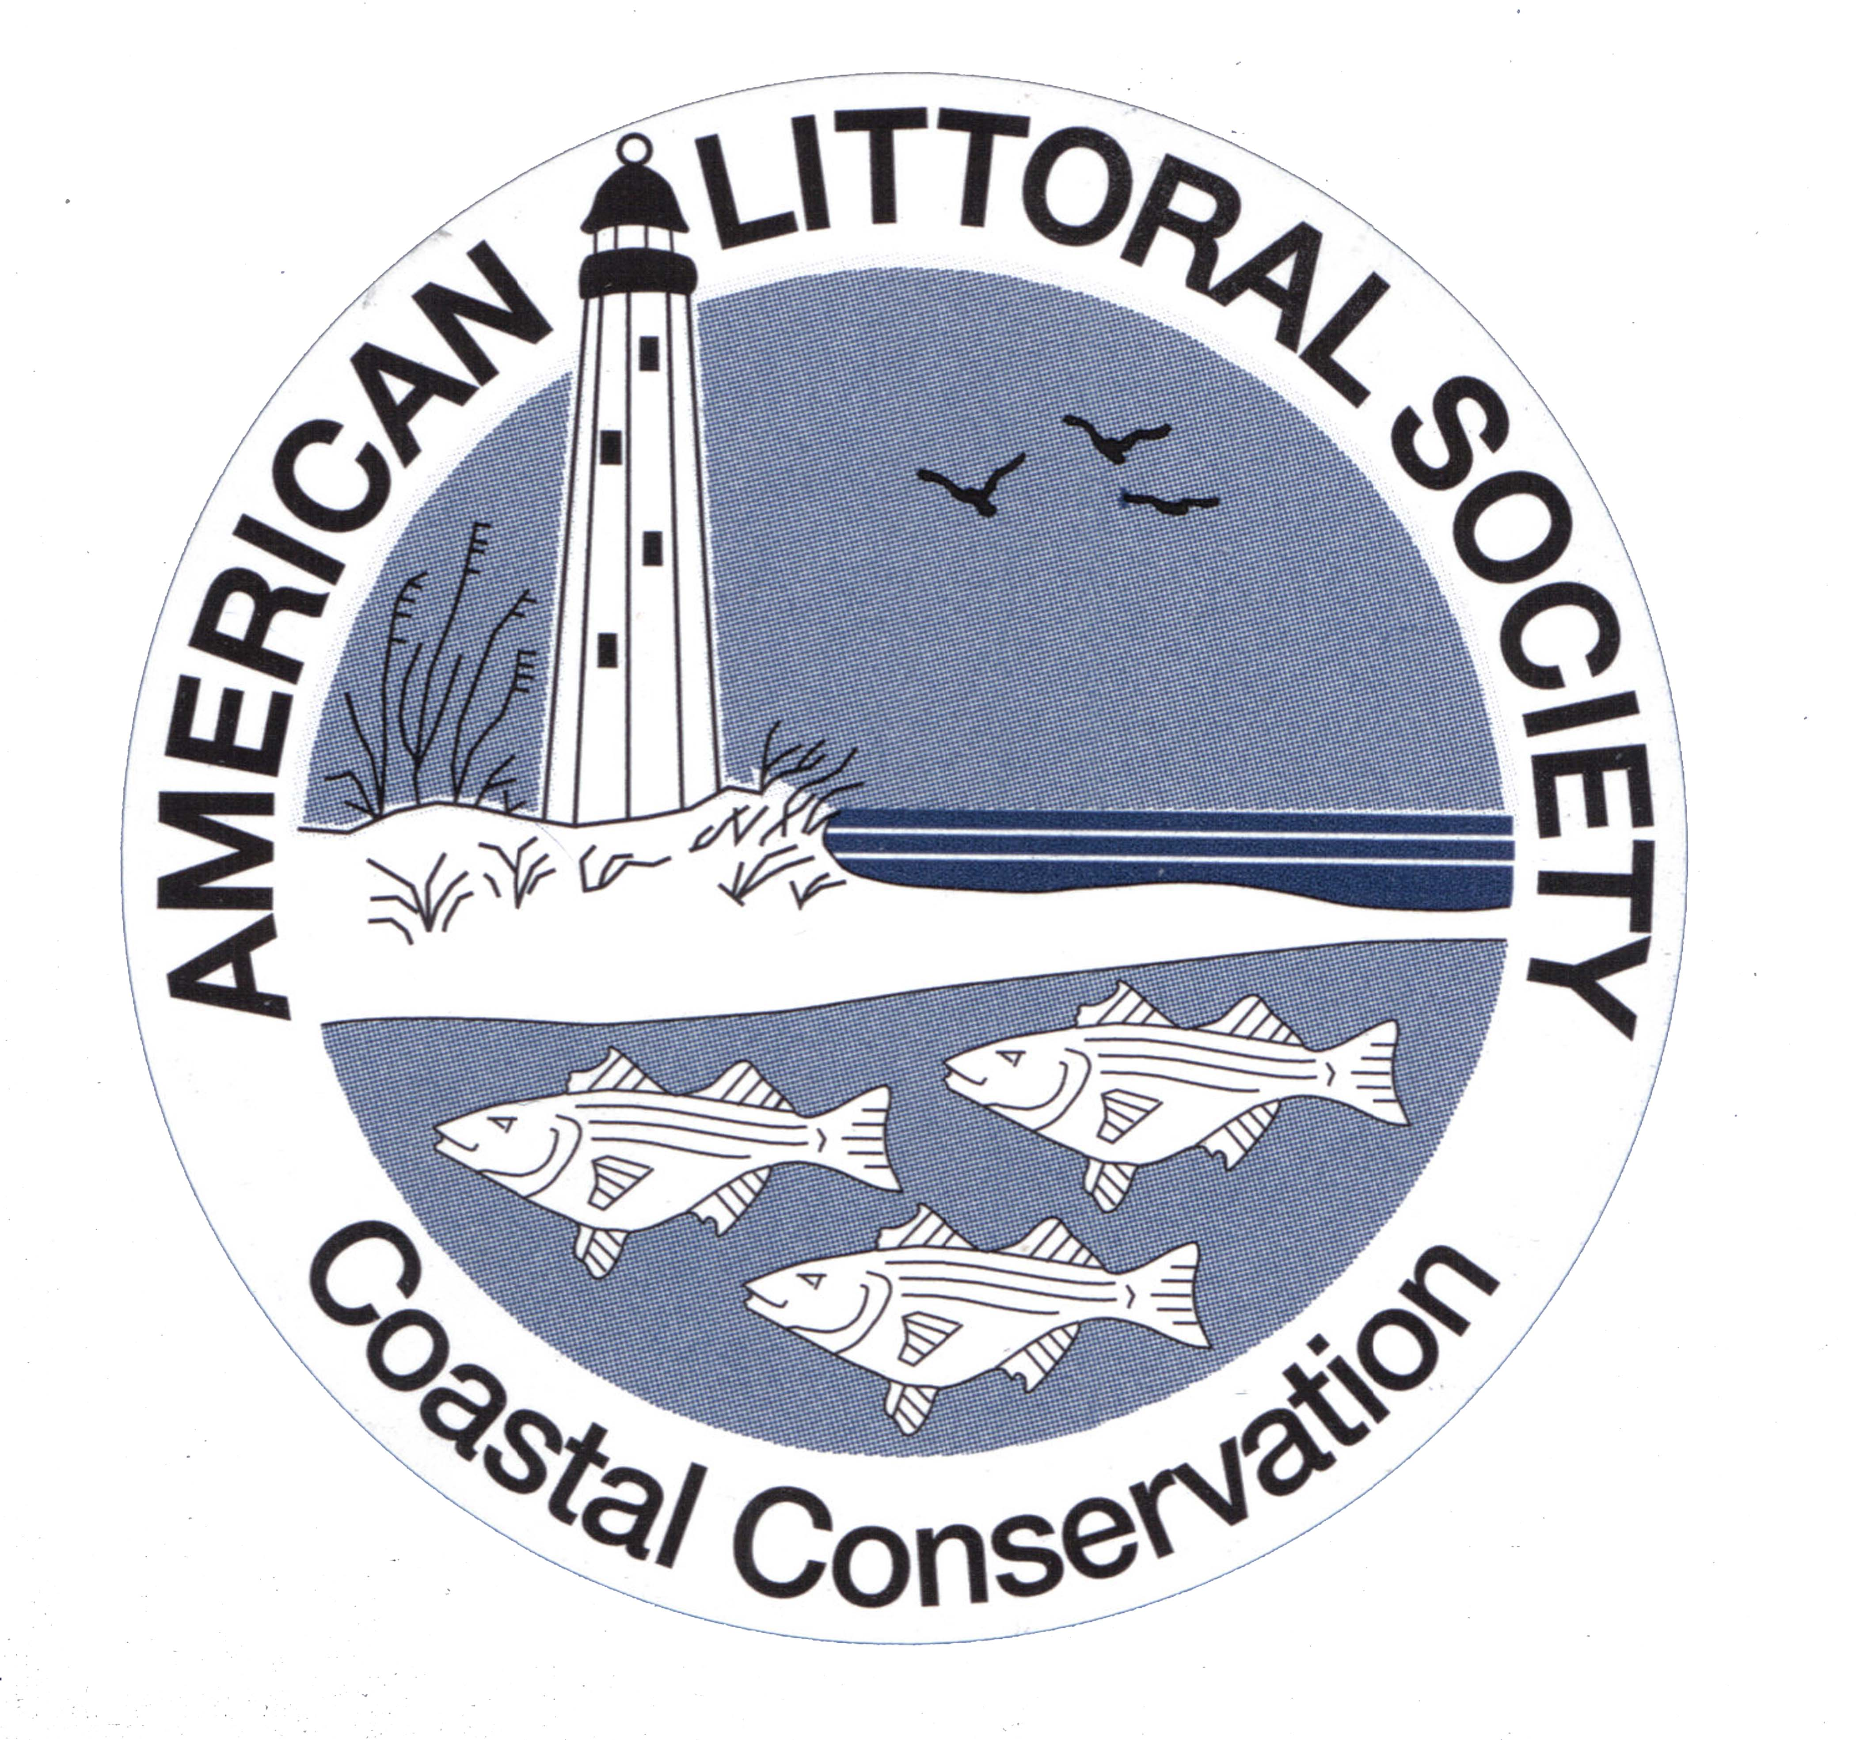
To find out more about the
New York State Beach Cleanup
visit us at www.NYSBeachCleanup.org.

To find out more about the
New York State Beach Cleanup
visit us at www.NYSBeachCleanup.org.

