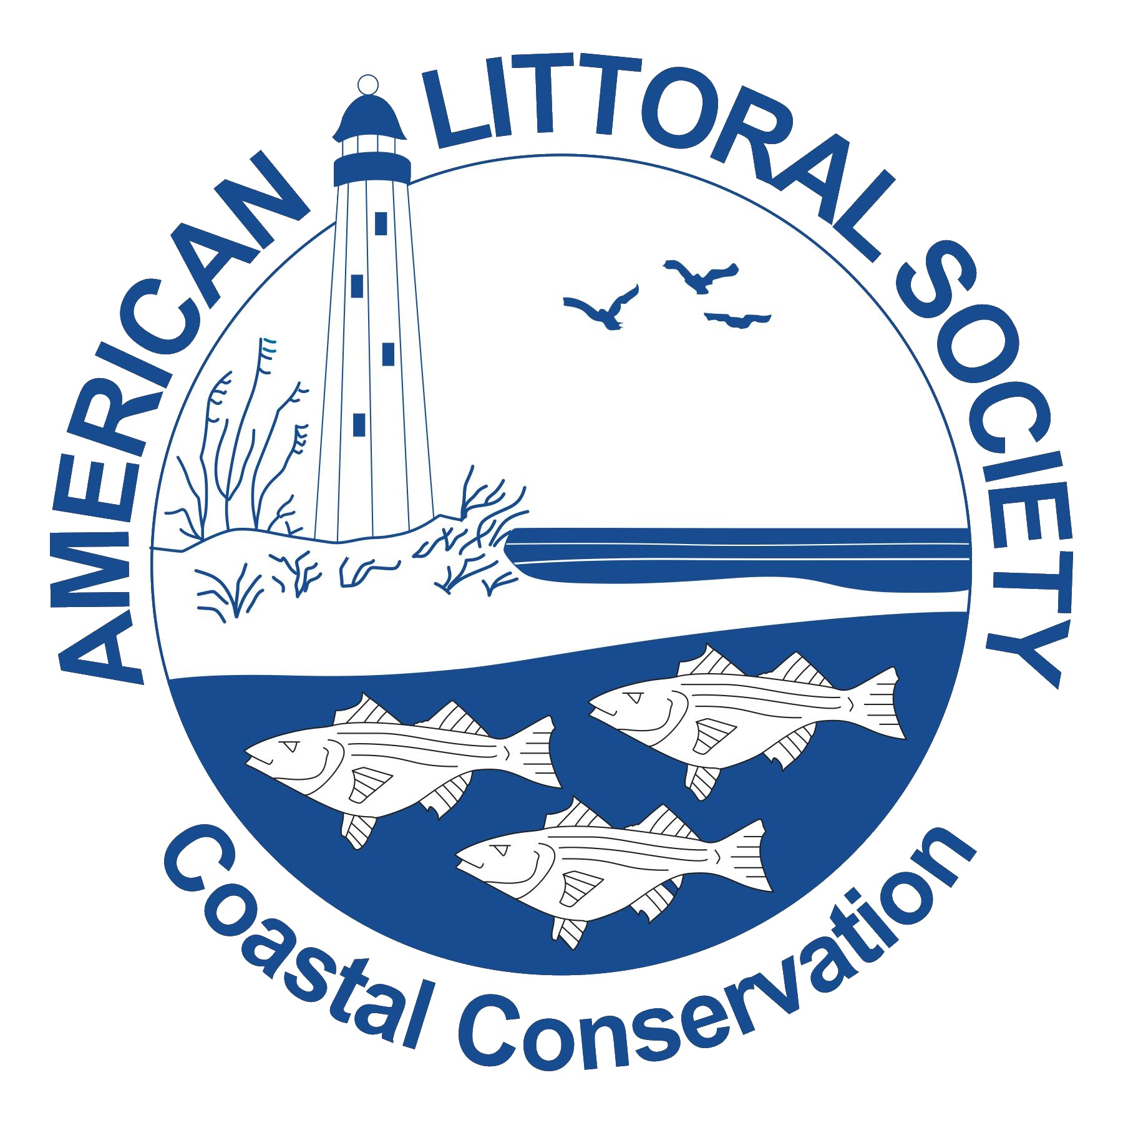
American Littoral Society
2022 NYS Beach Cleanup Report
Please mail or Email this form immediately after your cleanup!
- Please list information for each site on a separate sheet -

Beach Captain: _________________________________________ Organization: __________________________________

Telephone #: _______________________________ Email address: _____________________________________________

Date of cleanup: ______________ Site Name: ______________________________________________________________

Shoreline:___________________________ Site Coordinates: Longitude: ______________ Latitude: _________________
(ex. Atlantic Ocean, LIS, Hudson River, etc.) (to learn how to find the longitude and latitude of your site, visit www.nysbeachcleanup.org for instructions)

City/Town/Boro: ___________________________________________ County: ___________________________________

Nearest Road or Landmark: ______________________________________________________________________________

Mode of Data Collection (check one): Land (beach, shoreline, or inland) - Underwater - Watercraft Cleanup
Type of Environment: (check one.) Saltwater (Ocean/Bay/Estuary) - Freshwater (River/Stream/Lake) - Inland (No Water Body Present)
Is this cleanup part of: Long Island Sound? Jamaica Bay? (see map on other side or visit www.nysbeachcleanup.org)

LAND OR BEACH UNDERWATER WATERCRAFT
Number of Adults: _______________ Number of Divers: _______________ Number of Adults: ________________
Number of Children: _____________ Number of Children: _______________
Total weight of debris (lbs): Total weight of debris (lbs): Total weight of debris (lbs):
Distance Cleaned (mi): ____________ Distance Cleaned (mi): ____________ Distance Cleaned (mi): _____________
Number of Bags Used: Number of Bags Used: Number of Bags Used: _____________

Entangled animals?: ___________________________ Any peculiar finds?: _____________________________
(Indicate in what they were entangled in)

Record any fun or interesting activities that occurred during your cleanup that would be of interest to local or national media, to Ocean Conservancy or for the Littoral Society’s Annual Report: ________________________________________ __

_____________________________________________________________________________________________________
CHECKLIST Please EMAIL or MAIL the following items.

_____ Report Form _____ Coordinators Card _____ Volunteer Sign-in Sheets

Addressed envelope is provided should you choose to mail your forms.
Please fill in ALL requested information on the front of the Coordinators Card. (Do not return individual Data Cards).
Mail/Email:
Natalie Grant, NYS Beach Cleanup Coordinator, 28 West 9th Road, Broad Channel, NY 11693
Email: NYSBC@littoralsociety.org.

NYS has the fifth largest number of volunteers in the United States.
Your data can only be counted if your Coordinators Card and this Report Form are received ASAP.

WE THANK YOU FOR ALL YOUR HELP IN MAKING THIS EVENT SUCCESSFUL.
IT COULD NOT HAPPEN WITHOUT YOU!!!

Long Island Sound Boundaries
If your cleanup is within the outlined area, please check the box next to Long Island Sound.
For a more zoomed in view check out the Maps link at www.NYSBeachCleanup.org.

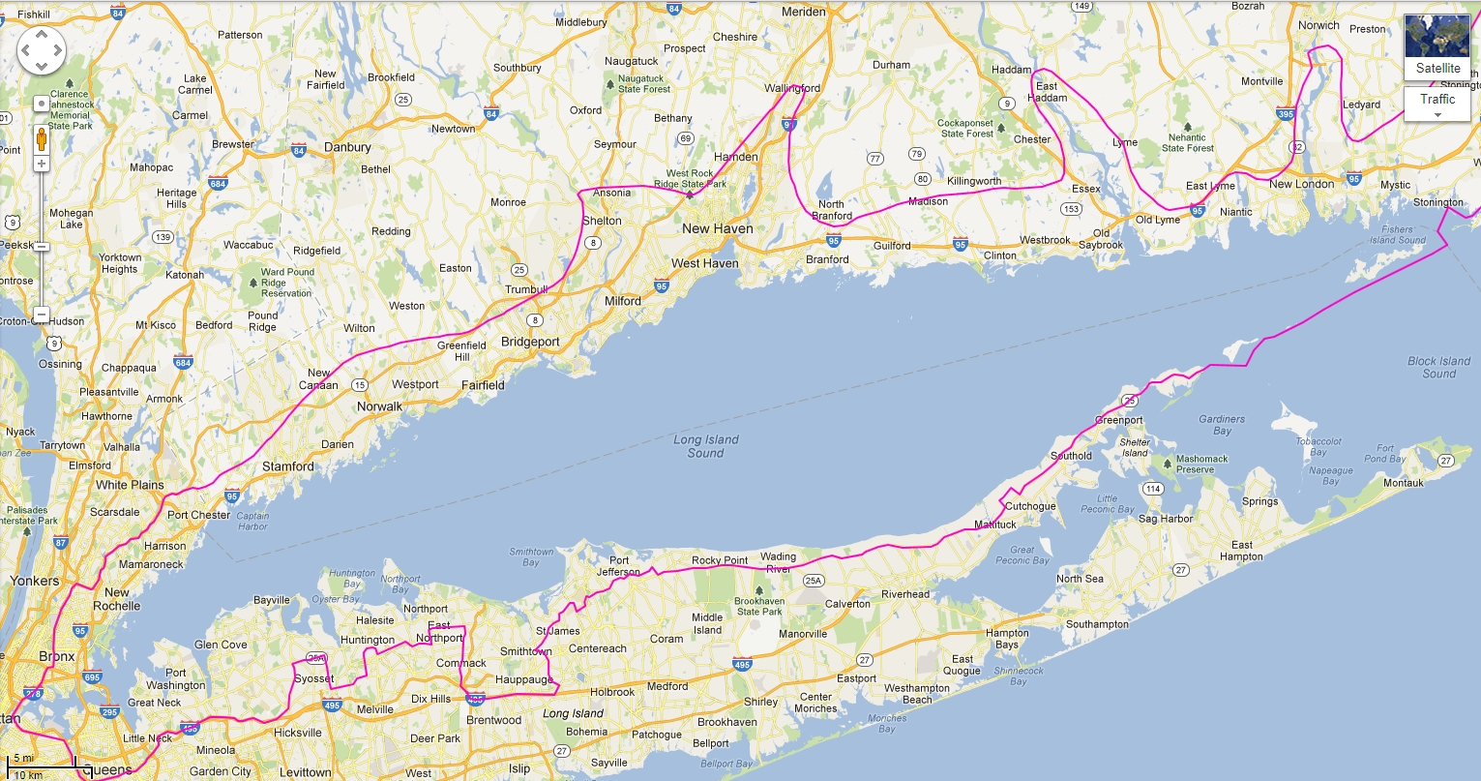

Jamaica Bay Boundaries
If your cleanup is within the outlined area, please check the box next to Jamaica Bay.
For a more zoomed in view, check out the Maps link at www.NYSBeachCleanup.org.
